HTTP Servlets

Servlet Life Cycle :

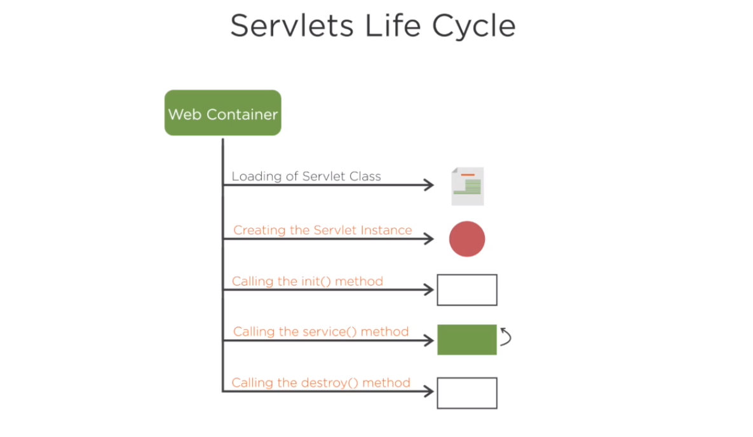

Tomcat creates the http Servlet request and response object

Designed for http protocol

Supports all HTTP-Verbs

------------------------------

Generic Servlet is protocol independent - http, ftp, etc

Service Method handles all requests

Can handle only simple Requests

Cant't track session data

------------------------------------------

---------------------------------------------------------

Ways to create a Servlet Page?

1. Class has to implement Servlet interface and override its methods

2. Class extends generic servlet -

Service method is invoked for every client request- two parameters ServletRequest, ServletResponse

Throws ServletException, IOException

3. Class extends HTTPServlet

--------------------------------

HTTPServletRequest Variable

getParameter(String name) : Returns the value of a request parameter

getParameterValues: Return an array of String

object containing all of the value

getParameterMap() : Returns a java.util.Map

getParameterNames() : Returns an enumeration of string objects containgi the names

of the parameters

